Task 3 – Creating a Class diagram and design pattern selection

**INTI International College Penang School of Engineering and Technology**

**3+0 Bachelor of Science (Hons) in Computer Science, in collaboration with Coventry University, UK**

**3+0 Bachelor of Science (Hons) in Computing, in collaboration with Coventry University, UK**

**Coursework cover sheet**

**Section A - To be completed by the student**

|  |  |
| --- | --- |
| Full Name: Clarence Wee Tze Wen | |
| CU Student ID Number: 12673140 | |
| Semester: 2 | |
| Session:  **April 2022** | |
| Lecturer:  **Nadhrah Abdul Hadi (nadhrah.abdulhadi@newinti.edu.my)** | |
| Module Code and Title:  **4067CEM Software Design** | |
| Assignment No. / Title:  **Continuous Assessment** | % of Module Mark:  **50** |
| Hand out Date:  **22nd April 2022** | Due Date:  **Task 1: 13 May 2022, by 11.59pm**  **Task 2: 1 July 2022, by 11.59pm**  **Task 3: 17 June 2022, by 11.59pm.**  **Task 4: 17 June 2022, by 11.59pm.**  **Task 5: 17 June 2022, by 11.59pm.** |
| Penalties: No late work will be accepted. If you are unable to submit coursework on time due to extenuating circumstances, you may be eligible for an extension. Please consult the lecturer. | |
| Declaration: I/we the undersigned confirm that I/we have read and agree to abide by the University regulations on plagiarism and cheating and Faculty coursework policies and procedures. I/we confirm that this piece of work is my/our own. I/we consent to appropriate storage of our work for plagiarism checking.  Signature(s): ________________________ | |

**Section B - To be completed by the module leader**

|  |  |  |
| --- | --- | --- |
| Intended learning outcomes assessed by this work:  1. Understand and apply appropriate concepts, tools and techniques to each stage of the software development  2. Understand and apply design patterns to software components in developing new software  3. Demonstrate an understanding of project planning and working to agreed deadlines, along with professional, interpersonal skills and effective communication required for software production  5. Demonstrate an awareness of, and ability to apply, social, professional, legal and ethical standards as documented in relevant laws and professional codes of conduct such as that of the Malaysian National Computer Confederation. | | |
| Marking scheme | Max | Mark |
| 1. User Story Mapping 2. Setting up a GitHub Repository 3. Creating a Class diagram and design pattern selection 4. Creating a Prototype User Interface and Usability Testing 5. Discuss the ethical issue related to the software | 20  10  30  20  20 |  |
| Total | 100 |  |

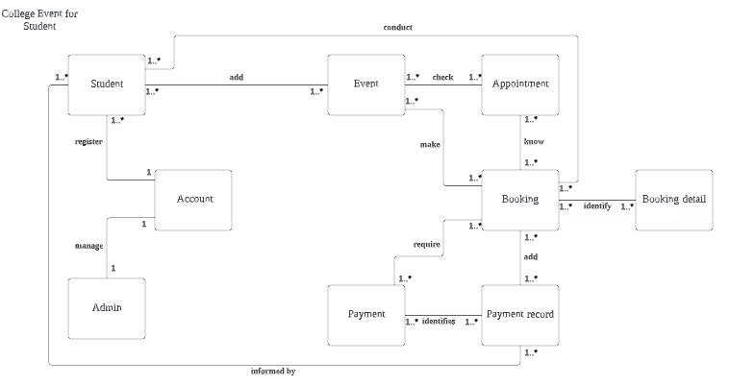**Class Diagram**

1. The account manages the information details from all admin and students to keep track personal information in system.
2. The event obtains the information from students and implement the event details into the appointment & booking system.
3. The booking manages all the information details obtained from the events, appointment and payment to implement in the system
4. The payment requires the information from booking to proceed every information into the payment record & the information will be informed to student for further reference.

**UML diagram- Facade Pattern**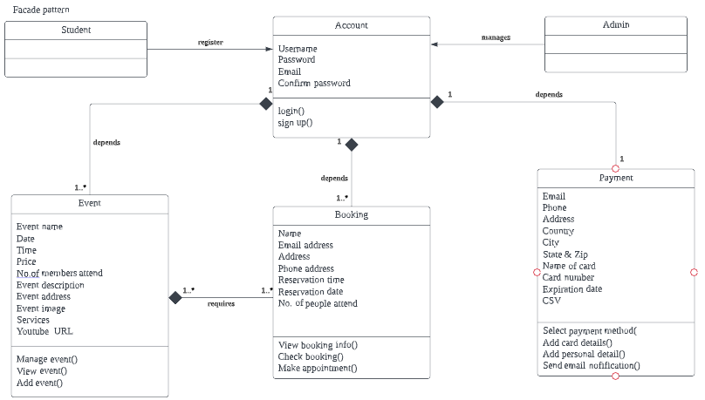

**Problem:**

How does students know of their upcoming events or current event status upon booking?

When student book multiple events at a single time, the system will only display the booking details of each of upcoming and current events in the event calendar. In certain way, students are unable to check their booking information for multiple events ahead of time unless they login & check the booking details in the booking interface. This will sometimes cause students to miss the events that they booked in the software unless an email notification which can be linked to a 3rd party such as Facebook or Google inform the students upon booking.

**Justification:**

To solve this problem, I choose façade design pattern. Façade pattern is process that hides the complexities of the system and provides a simple interface to the client using which the client can access the system and involves a single class which provides simplified methods required by client and delegates calls to methods of existing system classes. The accounts (object) require information from the students to allow access into the system. In the way, if student/admin is unable to acquire login information, they can’t access into the homepage interface to look through the rest of features. Upon booking the event (subject), the system requires information obtained from the type of events added & add the details credentials into the event calendar. The event calendar can be linked to Google to inform students of their event appointmentat the same timeother than checking it in the system. The payment(subject) acquires the booking information with own unique tickets & implement directly to the payment process for students.